Press Release

For Immediate Release 29 November 2012

To: Property Editors

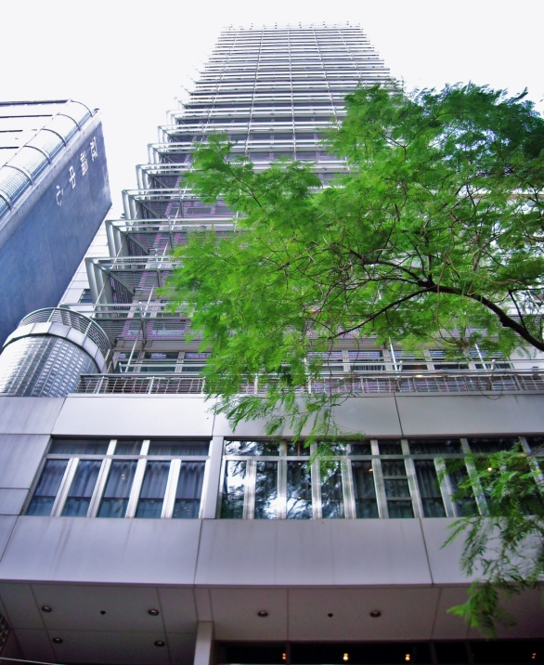

Soundwill Holdings Limited
Successfully Acquired An Investment Property at
No. 10 Knutsford Terrace, Tsim Sha Tsui

[29 November 2012] Soundwill Holdings Limited (the “Group”, stock code: 0878) is pleased to announce the successful acquisition of No. 10 Knutsford Terrace, Tsim Sha Tsui on 29 November 2012, for a consideration of HK$895,000,000. Completion of the sales transaction is expected for the first quarter of 2013. The transaction also marks the Group’s first commercial property acquisition of 2012, and will further enhance its overall leasing and investment portfolio in Hong Kong. Located in the heart of Tsim Sha Tsui’s bustling commercial and retail district, the acquired property is a 23-storey commercial complex with an aggregate gross floor area of approximately 87,000 square feet (based on a 12 times plot ratio).

Robust tourist arrival numbers continued to fuel Hong Kong’s burgeoning retail industry, thus ground floor shops and commercial properties in prime locations of the city are highly sought after and commands some of the highest rental rates in the world. Identifying such opportunities in the market, the Group has since established itself as a leading operator of quality commercial properties with the development of Soundwill Plaza and Soundwill Plaza II – Midtown and the recent investment in No. 10 Knutsford Terrace, Tsim Sha Tsui.

Following the anticipated opening of Soundwill Plaza II – Midtown in Causeway Bay and the completion of the Knutsford Terrace sales transaction in Tsim Sha Tsui, the Group will have a land bank of approximately 554,400 square feet for commercial leasing by 2013.

Leveraging on its extensive industry experience, the Group has, since its inception, been committed to the business of property assembly, property leasing and luxury residential developments on Hong Kong Island. The successful acquisition of a new commercial property will not only enhance the Group’s leasing and investment portfolio in Hong Kong, it will also open new sources of land bank for the Group to generate lucrative rental revenue in the long run. The Group will continue to actively source quality properties for acquisition, so as to facilitate long-term business growth.

Looking ahead, the Group will continue to implement appropriate development strategies to achieve sustainable growth in the long run. The Group will also actively source land sites with high appreciation potential in core locations of Hong Kong for self-development purposes and to increase its land bank for future development and ultimately, generate better return for its shareholders.

About Soundwill Holdings Limited
Established in 1978 and listed on the Main Board of the Hong Kong Stock Exchange in 1997, Soundwill Holdings Limited is principally engaged in old building assembly and acquisition, commercial leasing and property development.

~END~

Media enquiries:
Soundwill Holdings Limited
Candy Yeung Tel: 2916 2876 Email: candy.yeung@soundwill.com.hk

