Press Release
For Immediate Release

Soundwill Group’s Spotlight Project of the Year
“THE SHARP” – A New 24-hour Vertical Retail Project in Causeway Bay
All Units Pre-sold Within One Day
Highest Selling Price Achieved $48,100 Per Square Foot*

[3 January 2013] “THE SHARP”, developed by Soundwill Holdings Limited (the “Group”, stock code: 0878), is a brand new 24-hour vertical retail project in Causeway Bay’s Sharp Street East. The development is situated in the heart of Causeway Bay and enjoys a premium geographic location in the district’s famous retail triangle. A pre-sale event was held today (3 January) and all 29 units were sold within one day, with the highest selling price achieving a remarkable $48,100 per square foot (*calculated based on total gross floor area).

Ms. Vivian Chan, Executive Director of the Group said: ““THE SHARP” is the Group’s spotlight project of the year. Located in Causeway Bay’s highly sought after “Golden Triangle” retail district and surrounded by notable retail landmarks such as Times Square, the development is one-of-a-kind commercial project in the area and it enjoys an outstanding geographic advantage. “THE SHARP” was officially launched for sale today (3 January) and has immediately garnered exceptional market response, with all units sold within the first day at an average price of $33,576 per square foot. The selling price of the penthouse unit is also of note, achieving a record-high $48,100 per square foot and representing a sales price of $80,471,300. A total of 29 units were available for sale and represents a massive $1,500 million in sales proceeds.”

Located at 11 – 13 Sharp Street East, Causeway Bay, “THE SHARP” is a 32-storey commercial building with only one unit per floor. In particular, 29 units are available for sale. The size of typical units range from 1,567 to 1,586 square feet. The project is expected to be completed in the third quarter of 2015.

About Soundwill Holdings Limited
Established in 1978 and listed on the Main Board of the Hong Kong Stock Exchange in 1997, Soundwill Holdings Limited is principally engaged in old building assembly and acquisition, commercial leasing and property development.

~END~

For media enquiries:

Agnes Chok
Tel: 2916 2840
Email: agnes.chok@soundwill.com.hk

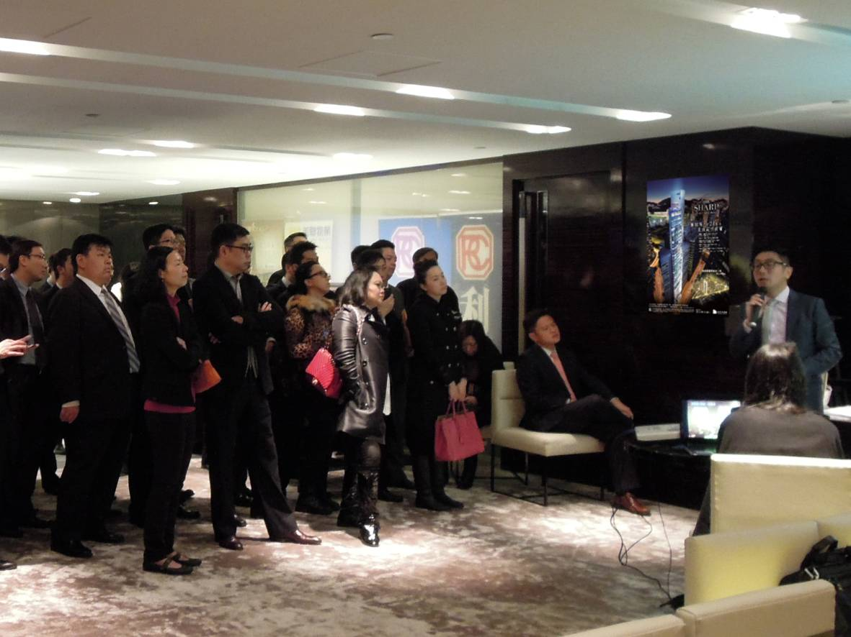

(Image above) Located at Sharp Street East, Causeway Bay, “THE SHARP” is a 32-storey commercial building with 29 units available for sale.

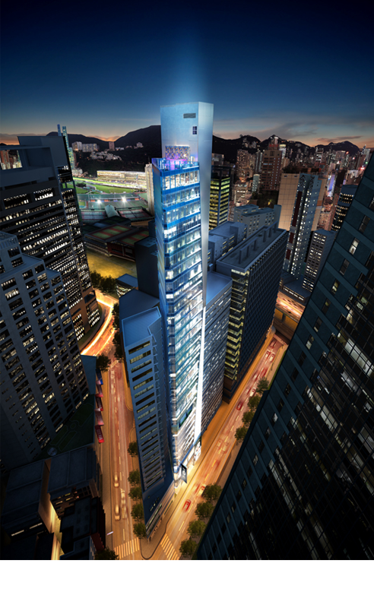

(Image above) The typical units of “THE SHARP” range from 1,567 to 1,586 square feet in size.

