Like our Facebook page
Watch us on YouTube
Follow us on Twitter

Contact: | Tom Gaffney | Jo Soo
Phone: | +852 2846 5803 | +852 2846 5823
Email: | tom.gaffney@ap.jll.com | jo.soo@ap.jll.com

Soundwill Unveils Spotlight Project「Soundwill Plaza II - Midtown」
at No. 1 Tang Lung Street

A future iconic landmark to reshape the retail and leasing marketing Causeway Bay

Hong Kong, 24 October 2012 – Soundwill Holdings Limited (Stock code: 0878) today announcedthe official name of its commercial project situated on No. 1-29 Tang Lung Street as「Soundwill Plaza II- Midtown」. The project is located in the traditional ‘golden triangle’ of the Causeway Bay retail market, with stunning 270 degree views across Victoria Harbour, Times Square and Causeway Bay. Soundwill announced the property’s name, its meaning behind and the project’s latest updates at a press conference today.

Named as 「Soundwill Plaza II- Midtown」, the project aims to continue the superior legacy of Soundwill Plaza, which is the most iconic commercial project developed by Soundwill. In addition, 「Midtown」, which stands for the heart of the city, not only targets to compete with the unique personality of Manhattan Midtown, but also targets to bring the utmost shopping experience to consumers by offering them with world-class brands and a combination of East and West cuisines. In every sense,「Soundwill Plaza II- Midtown」is not only a landmark, but an icon that stands for fashion and luxury, unique personality, confidence and taste.

Matthew Ng, Associate Director, Leasing and Marketing of Soundwill said: “Soundwill Plaza has always steered its development focus in the Hong Kong Island. Beloved by local consumers and tourists, Soundwill Plaza’s flagship properties have maintained the occupancy rates over 99% for long time, which also proves the market’s confidence at the Group. Following the huge success of Soundwill Plaza, 「Soundwill Plaza II- Midtown」will be our spotlight project in 2012 – 2013. With unparalleled design and unique location, we believe the development will soon become a new iconic landmark in the Causeway Bay market. To cater to the needs of target consumers, 「Soundwill Plaza II- Midtown」will provide consumers with diverse choices and superior services, aiming to attract different types of retailers and top-tier restaurants, bringing unparalleled unique shopping experience to the customers.

Tom Gaffney, Head of Retail, Hong Kong of Jones Lang LaSalle added:“「Soundwill Plaza II- Midtown」is another significant commercial project in Causeway Bay. Located in the traditional ‘golden triangle’ of the area, the development is destined to bring in more chic and enthusiastic consumers and attract top-tier international fashion, high end dining and lifestyle retailers. Alongside with current popular shopping destinations such as Times Square and Hysan Place, the completion of the project will further boost the vitality of the retail sector in Causeway Bay.”

“Looking forward, we are still optimistic about the outlook of Hong Kong’s retail market. There will be a 15% growth in retail rentals this year and at this point in the year we foresee approximately a further growth of 6 to 10 percent in 2013.” Tom added. “This new landmark project by Soundwill is destined to become a future icon in Causeway Bay and will help to reshape the current landscape of the retail and leasing market in the area.”

Situated on No. 1-29 Tang Lung Street, 「Soundwill Plaza II- Midtown」is a 31-storey building, with a gross floor area of approximately 216,865 sq.ft gross. The project is targeted for completion in Q3 2012. Located in the traditional ‘golden triangle’ in Causeway Bay, 「Soundwill Plaza II- Midtown」allows stunning 270 degree views across Victoria Harbour, Times Square and Causeway Bay, including a super high-ceiling retail podium of approximately 32,000 sq.ft., with approximately 70 metres of street frontage and iconic glass box façade and eight storeys of international food and beverage offerings with alfresco areas. The ground floor to the 2/F is approximately 11,000-12,000 sq.ft per floor.; 3/F-5/F is approximately 7,000 sq.ft per floor.; the lower standard floor is approximately 6,800-7,800 square feet per floor; the higher-level standard floors is approximately 7,800-8,600 sq.ft per floor; and the food and beverage floors on the 25/F-30/F is approximately 6,800-8,500 sq.ft per floor.「Soundwill Plaza II- Midtown」has engaged Woods Bagot, an award winning global studio and architect as the façade designer and Jones Lang LaSalle as the sole leasing agent.

– Ends –

About Soundwill Holdings Limited
Established in 1978 and listed on the Main Board of the Hong Kong Stock Exchange in 1997, Soundwill Holdings Limited is principally engaged in old building assembly and acquisition, commercial leasing and property development.

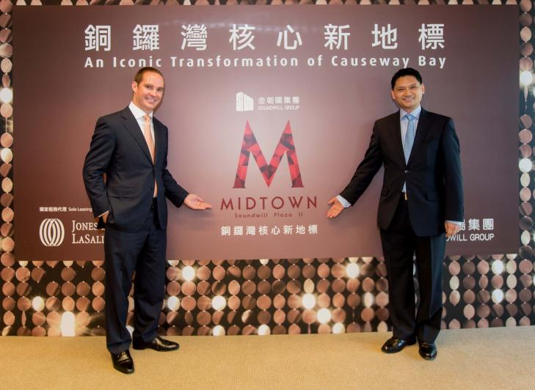

Matthew Ng, Associate Director, Leasing and Marketing of Soundwill (right) and Tom Gaffney, Head of Retail Hong Kong of Jones Lang LaSalle unveil the name of Soundwill Holdings Limited’s latest project –
「Soundwill Plaza II - Midtown」.

About Jones Lang LaSalle
Jones Lang LaSalle (NYSE:JLL) is a professional services firm specializing in real estate. The firm offers integrated services delivered by expert teams worldwide to clients seeking increased value by owning, occupying or investing in real estate. With 2011 global revenue of USD 3.6 billion, Jones Lang LaSalle serves clients in 70 countries from more than 1,000 locations worldwide, including 200 corporate offices. The firm is an industry leader in property and corporate facility management services, with a portfolio of approximately 2.1 billion square feet worldwide. LaSalle Investment Management, the company’s investment management business, is one of the world’s largest and most diverse in real estate with USD 47.2 billion of assets under management.
Jones Lang LaSalle has over 50 years of experience in Asia Pacific, with over 22,200 employees operating in 79 offices in 14 countries across the region. The firm was named ‘Best Property Consultancy’ in nine Asia Pacific countries at the International Property Awards Asia Pacific 2012, in association with HSBC, and was highly commended in a further three countries.
For further information, please visit our website, www.joneslanglasalle.com.hk│ 6/F Three Pacific Place 1 Queen’s Road East Hong Kong

